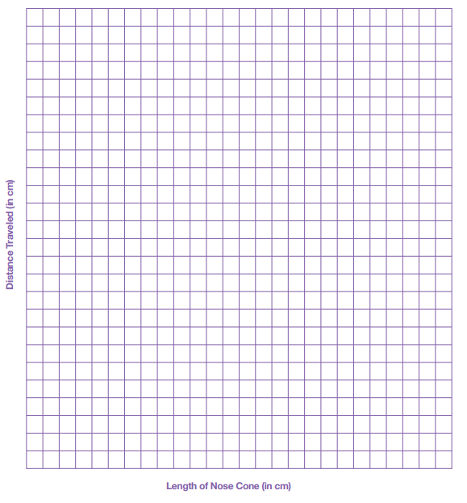
Straw Rocket Graph Analysis
Here you can collate and present your data in a line graph.

