Good

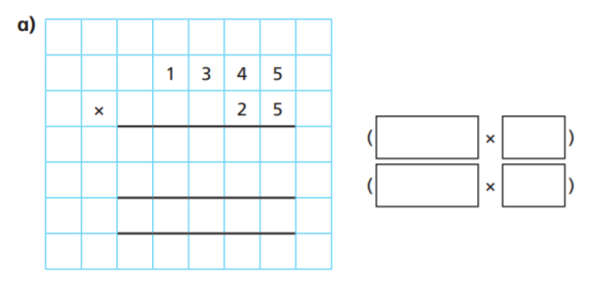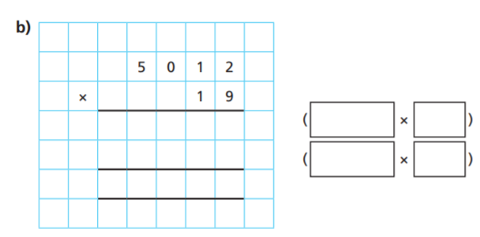
Good  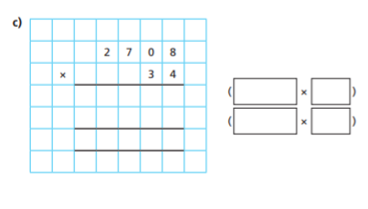 | Amazing  Write out and solve these questions in your book  - 4511 x 23  - 5037 x 15  - 74 x 1156  - 8001 x 26  - 9261 x 11  - 49 x 3860
Awesome  A shop buys football shirts for £39 each and sells them for £49 each.  - The shop buys 2,700 football shirts. How much does it cost?  - b) The shop sells all the football shirts. How much profit does it make? | Awesome  Calculate 9,999 × 99  Show workings in your book

