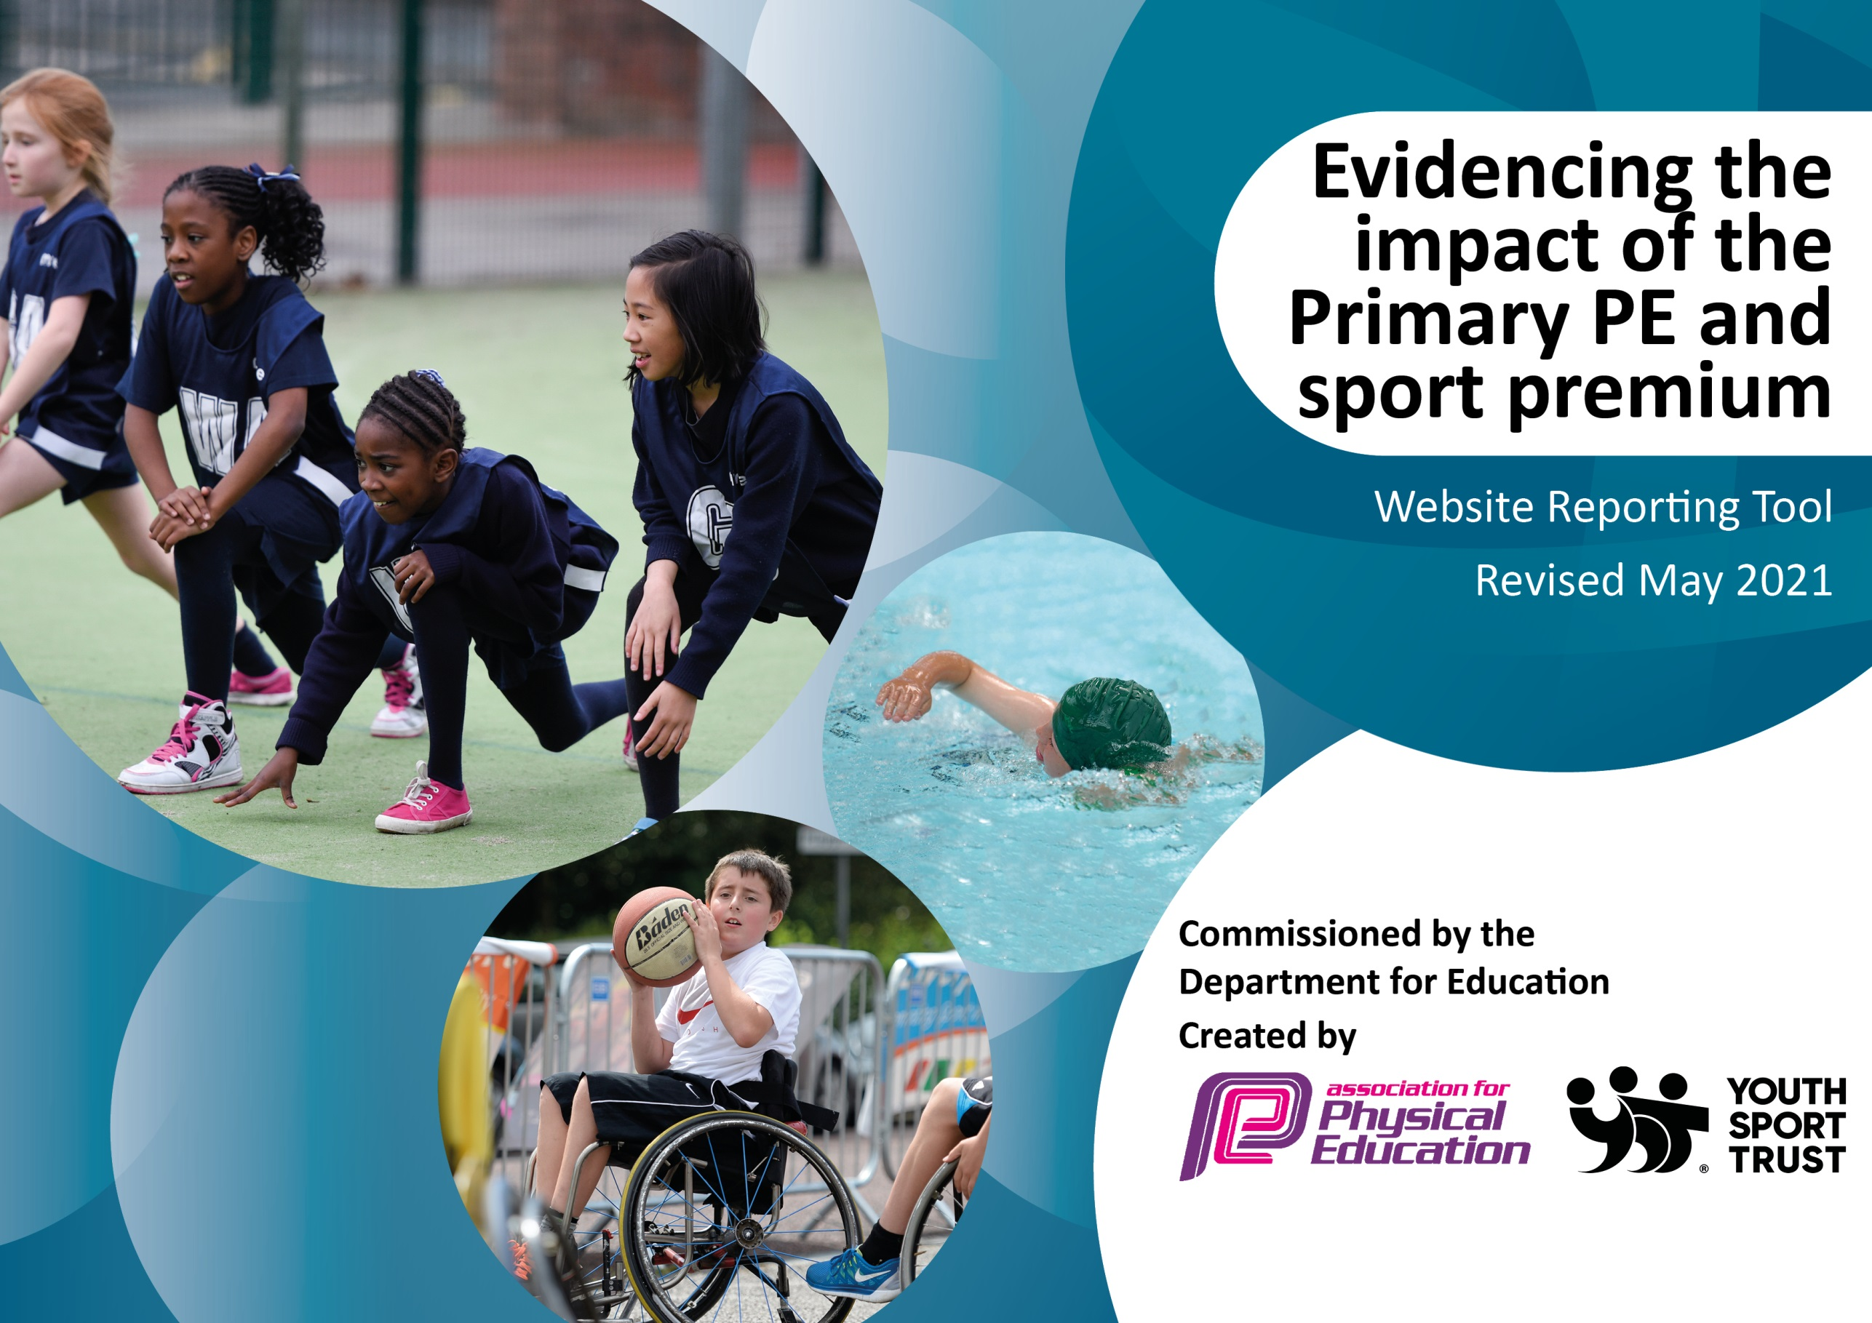

It is important that your grant is used effectively and based on school need. The Education Inspection Framework (Ofsted 2019 p64) makes clear there will be a focus on ‘whether leaders and those responsible for governors all understand their respective roles and perform these in a way that enhances the effectiveness of the school’.

Under the Quality of Education criteria (p41) inspectors consider the extent to which schools can articulate their curriculum (INTENT), construct their curriculum (IMPLEMENTATION) and demonstrate the outcomes which result (IMPACT).

To assist schools with common transferable language this template has been developed to utilise the same three headings which should make your plans easily transferable between working documents.

Schools must use the funding to make additional and sustainable improvements to the quality of Physical Education, School Sport and Physical Activity (PESSPA) they offer. This means that you should use the Primary PE and sport premium to:

- Develop or add to the PESSPA activities that your school already offer
- Build capacity and capability within the school to ensure that improvements made now will benefit pupils joining the school in future years
- The Primary PE and sport premium should not be used to fund capital spend projects; the school’s budget should fund these.
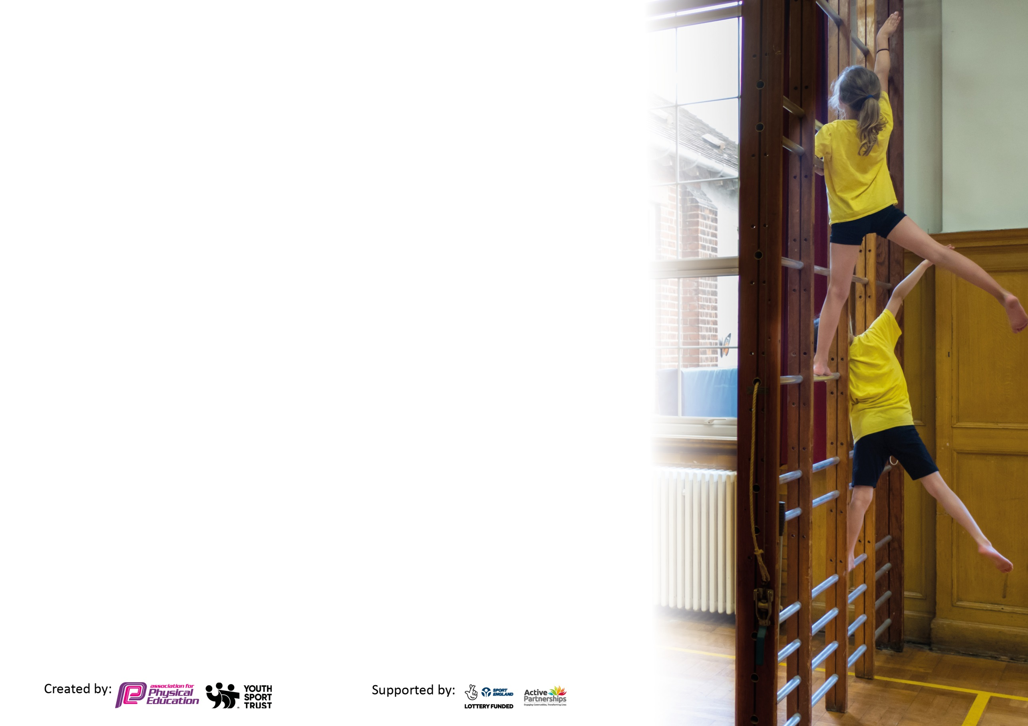
Please visit gov.uk for the revised DfE guidance including the 5 key indicators across which schools should demonstrate an improvement. This document will help you to review your provision and to report your spend. DfE encourages schools to use this template as an effective way of meeting the reporting requirements of the Primary PE and sport premium.

We recommend you start by reflecting on the impact of current provision and reviewing the previous spend.

Schools are required to publish details of how they spend this funding, including any under-spend from 2019/2020, as well as on the impact it has on pupils’ PE and sport participation and attainment by the end of the summer term or by 31st July 2021 at the latest.

We recommend regularly updating the table and publishing it on your website throughout the year. This evidences your ongoing self-evaluation of how you are using the funding to secure maximum, sustainable impact. Final copy must be posted on your website by the end of the academic year and no later than the 31st July 2021. To see an example of how to complete the table please click HERE.

Please note: Although there has been considerable disruption in 2020 it is important that you publish details on your website of how you spend the funding - this is a legal requirement.
Support for review and reflection - considering the 5 key indicators from DfE, what development needs are a priority for your setting and your pupils now and why? Use the space below to reflect on previous spend and key achievements and areas for development.

N.B. In this section you should refer to any adjustments you might have made due to Covid-19 and how these will influence further improvement.
Key achievements to date until July 2020: | Areas for further improvement and baseline evidence of need:
- Collected teacher’s feedback on PE scheme of work  - Social distanced plans were implemented  - Children in and out of school partook in virtual challenges throughout Lockdown  - 100% attendance to all face to face local tournaments  - Accessed CPD to aid differentiation and gymnastics  - Employed PE coach to offer alternative games and drills in athletics | - Introduce whole school initiative (daily mile- PE lead has looked into step trackers for each class)  - Reintroduce clubs back into the school day  - Implement new playground set up including football nets and borders  - Look into specific coaching for lessons/after school clubs

Did you carry forward an underspend from 2019-20 academic year into the current academic year? YES
Total amount carried forward from 2019/2020 £9,018.00
+ Total amount for this academic year 2020/2021 £17,750.00
= Total to be spent by 31st July 2021 £26,768 - current plans include spending on athletics sessions, multi goal sports panels,
socketed netball posts - these will probably be installed in the Autumn term 2021 due to planned removal of an unsafe portacabin during the summer
Meeting national curriculum requirements for swimming and water safety.

N.B Complete this section to your best ability. For example you might have practised safe self-rescue techniques on dry land which you can transfer to the pool when school swimming restarts.
Due to exceptional circumstances priority should be given to ensuring that pupils can perform safe self rescue even
if they do not fully meet the first two requirements of the NC programme of study.
What percentage of your current Year 6 cohort swim competently, confidently and proficiently over a distance of at least 25 metres?  N.B. Even though your pupils may swim in another year please report on their attainment on leaving primary school at the end of the summer term 2021.  Please see note above. | 65%
What percentage of your current Year 6 cohort use a range of strokes effectively [for example, front crawl, backstroke and breaststroke]?  Please see note above. | 80%
What percentage of your current Year 6 cohort perform safe self-rescue in different water-based situations? | 38%
Schools can choose to use the Primary PE and sport premium to provide additional provision for swimming but this must be for activity over and above the national curriculum requirements. Have you used it in this way? | No

Action Plan and Budget Tracking
Capture your intended annual spend against the 5 key indicators. Clarify the success criteria and evidence of impact that you intend to measure to evaluate for pupils today and for the future.

Academic Year: 2020/21 | Total fund allocated: £ | Date Updated:
Key indicator 1: The engagement of all pupils in regular physical activity – Chief Medical Officers guidelines recommend that primary school pupils undertake at least 30 minutes of physical activity a day in school |  |  |  | Percentage of total allocation:
 |  |  |  | %
Intent | Implementation |  | Impact
Your school focus should be clear what you want the pupils to know and be able to do and about  what they need to learn and to  consolidate through practice: | Make sure your actions to achieve are linked to your intentions: | Funding allocated: | Evidence of impact: what do pupils now know and what can they now do? What has changed?: | Sustainability and suggested next steps:
To facilitate all children with the opportunity to access and progress in PE at their own level | Participation in Shoreham Academy’s virtual tournaments |  | Due to the coronavirus, children worked to beat their personal best scores in various challenges throughout the academic year. We participated in every challenge bar one and were first place until the last three challenges, where we got knocked to fifth place. | Virtual tournaments will hopefully be replaced by face-to-face tournaments next year.
To promote athletics within the school | PE coach to offer games and activities which are varied and any children can join in. |  | Children and teachers have noticed children are more active and the structure promotes better behaviour. | Offer these activities as an after school club
Key indicator 2: The profile of PESSPA being raised across the school as a tool for whole school improvement |  |  |  | Percentage of total allocation:
 |  |  |  | %
Intent | Implementation |  | Impact
Your school focus should be clear what you want the pupils to know and be able to do and about  what they need to learn and to  consolidate through practice: | Make sure your actions to achieve are linked to your intentions: | Funding allocated: | Evidence of impact: what do pupils now know and what can they now do? What has changed?: | Sustainability and suggested next steps:
Subject area is clear on the website and children/parents can easily find resources | - Website has a clear PE area  - Ideas and links are shared  - Links with Ofsted/ National Curriculum are clear |  | Parents and children are accessing opportunities for physical exercise at home. | Keep this information available on the website.

Key indicator 3: Increased confidence, knowledge and skills of all staff in teaching PE and sport |  |  |  | Percentage of total allocation:
 |  |  |  | %
Intent | Implementation |  | Impact
Your school focus should be clear | Make sure your actions to | Funding | Evidence of impact: what do | Sustainability and suggested
what you want the pupils to know | achieve are linked to your | allocated: | pupils now know and what | next steps:
and be able to do and about | intentions: |  | can they now do? What has
what they need to learn and to |  |  | changed?:
consolidate through practice:
Teachers to observe Shoreham Academy coaches and buy into their CPD scheme, in order to gain ideas for activities and sports to teach within a PE lesson. | Shoreham Academy coaching to promote high quality teaching and learning outcomes for pupils.  Teachers to observe techniques and methods used to deliver dance and gymnastics sessions. |  | Teachers have accessed CPD (some face to face and some online). Teachers have implemented the skills and activities they have observed. Teachers have reported that they now feel more confident teaching gymnastics, ball skills and also differentiating. | Discuss with teachers what they would like CPD on next year.
To implement PE scheme of work- peplanning.co.uk | Teachers to use peplanning.co.uk in line with the yearly overview coverage (altered during Covid) that the PE lead has devised, ensuring progression across the school. |  | Teachers have verbally stated that they feel a lot more confident delivering PE, now that aims and skills are clear. Progression is clear both within a topic and lesson. Teachers think the diagrams, differentiation and clear break down of tasks have boosted their confidence. Children benefit as lessons are more directed and carried out at a quicker pace. | Peplanning.co.uk will be used again in the academic year of 2021/2022
Ensure PE is being accessed with new arrangements | Teachers will use and adapt socially distanced PE sessions (found by PE lead) to the needs of their class |  | All teachers used socially distanced plans throughout the restricted periods. | Hopefully this won’t need to continue next year.
Key indicator 4: Broader experience of a range of sports and activities offered to all pupils |  |  |  | Percentage of total allocation:
 |  |  |  | %
Intent | Implementation |  | Impact
Your school focus should be clear | Make sure your actions to | Funding | Evidence of impact: what do | Sustainability and suggested
what you want the pupils to know | achieve are linked to your | allocated: | pupils now know and what | next steps:
and be able to do and about | intentions: |  | can they now do? What has
what they need to learn and to |  |  | changed?:
consolidate through practice:
To ensure there are enough, high quality pieces of equipment for every lesson | Numerous stock checks to be completed throughout the year, before each new topic has been delivered. |  | Appropriate equipment has been ordered and used to ensure all classes and ages can access the sports at their own level. There are now stop watches to aid children in monitoring their own achievements. | Ensure equipment is appropriately stored and looked after. Continue to order any resources prior to a teaching topic.

Key indicator 5: Increased participation in competitive sport |  |  |  | Percentage of total allocation:
 |  |  |  | %
Intent | Implementation |  | Impact
Your school focus should be clear | Make sure your actions to | Funding | Evidence of impact: what do | Sustainability and suggested
what you want the pupils to know | achieve are linked to your | allocated: | pupils now know and what | next steps:
and be able to do and about | intentions: |  | can they now do? What has
what they need to learn and to |  |  | changed?:
consolidate through practice:
To encourage more children to partake in different tournaments and competitions. | The school to buy into Shoreham Academy competitions CPD for the academic year, to give different pupils the chance to represent the school locally.  Teachers to provide training before a tournament to boost confidence.  Children should all be given a chance to put themselves forward to compete in age-appropriate tournaments. |  | The children have participated in all tournaments offered by Shoreham Academy.  To encourage fun and participation, we have invited whole classes along rather than specific teams.  The children were also encouraged to partake in the virtual tournaments during Lockdown. | St. Peter’s will buy into the Shoreham Academy Competitions again next year. We will continue to aim to attend all tournaments.

Signed off by
Head Teacher:
Date:
Subject Leader: | Keri Heffernan
Date: | 06.07.2021
Governor:
Date:

