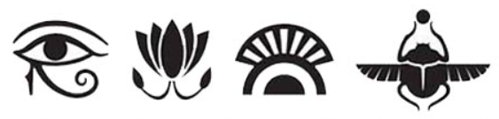
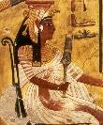
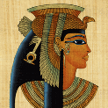
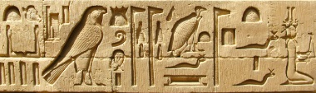
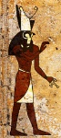
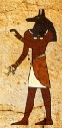
Homework Planner

Theme: Ancient Egyptians
Autumn Term: First half |  | Year Group: Four
This half term, we will be travelling back in time to Ancient Egypt! We will be finding out about the mummifying process, the awe-inspiring pyramids and the most memorable pharaohs. Our class reader this half term will be ‘Mr Stink’ by David Walliams.
Choice of activity: | Art-based |  | Research-based | Writing-focus
Please choose one of the following:  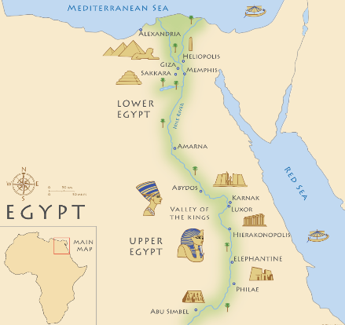 | Create your own Pharaoh mask.  Death masks were made in the likeness of the person who had deceased. They would often have slightly enlarged eyes, a faint smile and also painted jewellery and makeup.  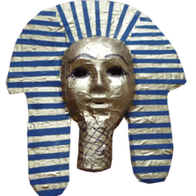  Use any materials that you wish, to create a death mask that looks very expensive and treasured. |  | The ancient Egyptians invented one of the earliest known writing systems used call hieroglyphs, which comes from a Greek word meaning ‘sacred carving’.  Research hieroglyphs and use what you learn to create a nicely- presented hieroglyph of your name.  This website will really help :  https://www.bbc.co.uk/bitesize/articles/zvw3mfr#z3gdwnb  (Google Search words: bbc bitesize hieroglyphics)  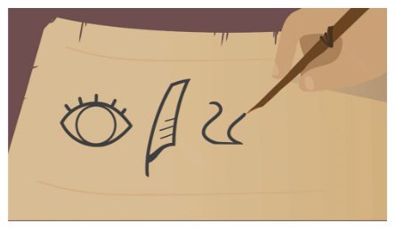 | Imagine you are an ancient Egyptian. Describe a typical day in your life. You can choose if to be a pharaoh, slave or normal citizen.  This video gives you an idea of what life was like :  https://www.youtube.com/watch?v=lZOPWSXMvzI  (Search: Introducing Ancient Egypt | History - Lost Land on Youtube)  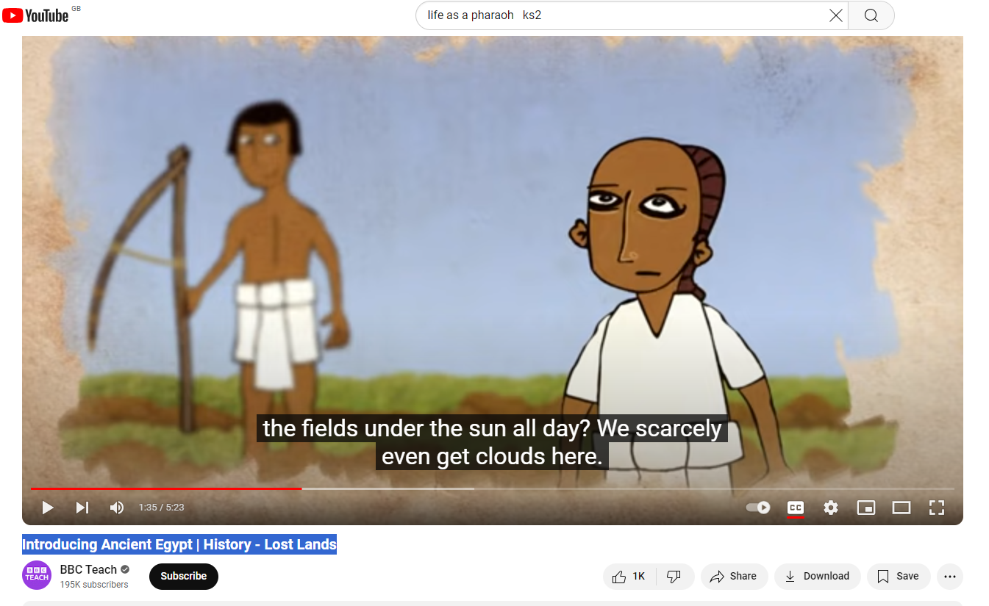
Themed tasks to be in: | By Wednesday 19th October 2026
6Regular, ongoing tasks | Daily reading: 25 minutes at home every day
6Regular, ongoing tasks | Times tables to be learned for five minutes every evening using Percy Parker songs, Times Table Rock Stars or other chosen methods. We’ll use speed tables sessions in school to see how you are improving…
6Regular, ongoing tasks | The children have been given maths and English homework books. These need to be completed each week and brought in by Friday.
6Regular, ongoing tasks | Spellings to be learned for five minutes every evening leading up to a test fortnightly, on Fridays.  Thank you for all your support with these home tasks.

