Homework Planner Year 4: Shoreham: Then and now
Summer Term: 1 |  | Year Group: Four
For the Summer term, we will be studying Shoreham in the past and in the present. For the first half term, we will be looking closely at our local area and using map skills to explore key geographical features of Shoreham. We will also be thinking about Shoreham’s natural and human-made resources such as the beach, the South Downs, river and shopping centre and how they affect our lives.

Choice of activity: | Art-based |  | Research-based | Writing-focus
Please choose one of the following:  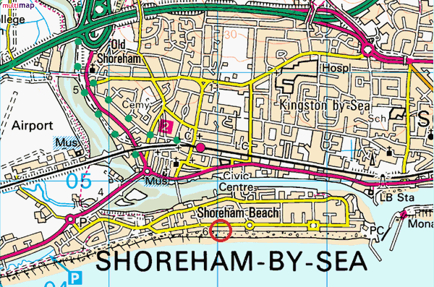 |  |  |  | Write a letter to Adur Council with tips on how they could improve our local environment. What would you love to see built or made better near you?  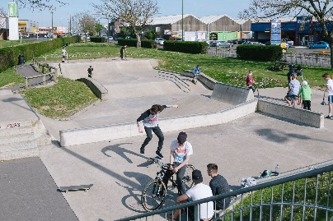  Write a review about your favourite place in Shoreham. Describe its history, what you can do there, why you like it and what you think could be done to make it even better.
  *Create a sculpture that could be placed somewhere in Shoreham. The sculpture should reflect our local community.
  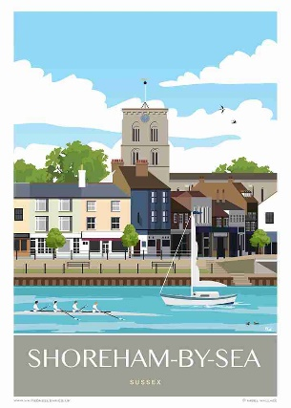
  or
  Design a tourist poster to attract tourists to Shoreham
  *Research a Shoreham landmark,
  for example, Shoreham Harbour Lifeboat centre, The Power station. Brighton City airport or Shoreham Fort. You can present your work anyway you would like (a song, in writing, as a fact file etc).
  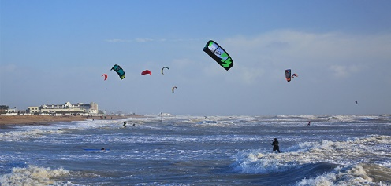
  *Research what outdoor activities you can do in Shoreham. Create a PowerPoint about it. (Some ideas could include: kitesurfing, surfing, mountain biking on the South Downs, scuba diving, fishing, swimming, sailing kayaking and canoeing).
Themed tasks to be in: | The week beginning- Monday 18th May 2026  We will be sharing these in school and once shared, these will be sent home to keep/ enjoy over the holiday.
Regular, ongoing tasks | Daily reading: 25 minutes at home every day.  Please encourage your child to record their reading progress in their reading journal.  They are expected to do this four times a week.
Regular, ongoing tasks | Times tables to be learned for five minutes every evening using Times Table Rock Stars or other chosen methods.  We’ll use speed tables and Percy Parker sessions in school to see how they are improving.
Regular, ongoing tasks | Quick bursts of Maths and English homework will be sent out every week.
Regular, ongoing tasks | Spellings to be learned for five minutes every evening leading up to a test fortnightly.  Thank you for your continued support.

