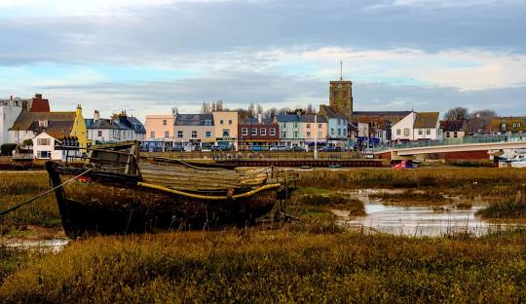
Shoreham: Then and now: History Knowledge organiser
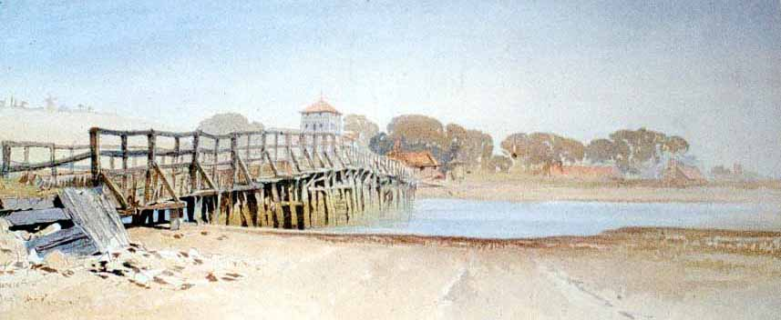
Key Vocabulary
Chronological | In date order from earliest to latest
Settlement | A place where people have stayed to live like a town or village.
BC | BC stands for the time "Before Christ,"
AD | AD stands for "Anno Domini," which is Latin for "in the year of the Lord.
Normans | The Normans were people who came from Normandy, a region in northern France. Later, they famously invaded and conquered England in 1066
Conquest | Conquest" means winning or taking control of something by force, like a country or a game.
Topic Questions
Why did people choose to build a settlement in Shoreham?
How old is Shoreham?
How has Shoreham changed over time?
What important events happened in Shoreham?
Who built St Mary de Haura Church in Shoreham?
What were the Swiss Gardens and what happened to them?


