Key vocabulary
Axis | An imaginary line which something rotates around.
Celestial body | An object in space.
Earth | The planet that we live on.
Gravitational force | A non-contact force caused by objects with mass pulling each other.
Gravity | A non-contact force caused by objects with mass pulling each other.
Geocentric model | A model that puts Earth at the centre of the Solar System.
Heliocentric model | A model that puts the Sun at the centre of the Solar System.
Moon | A natural satellite that orbits Earth.
Orbit | The path an object takes around another object because of gravity.
Planets | A roughly spherical object which orbits a star.
Pluto | A former planet that was reclassified as a dwarf planet.
Rotate | To spin around an axis.
Satellite | An object that orbits a planet or a star.
Solar system | The Sun and the other bodies that orbit it.
Sun | The star at the centre of our Solar System.
Learning Objective | Pupil | Teacher
Can I understand what makes up the Solar System?
Can I name the 8 planets and their features?
Can I create a model of the Solar System?
Can I explain the motion of the Earth and planets?
Can I explore how ideas about the Solar System have changed over time?
Can I explain how the Earth moves?
Can I explain how night and day occur?
Can I explore the Moon and its features?
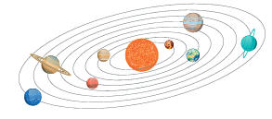
Year 5 Science: Space Term: Spring
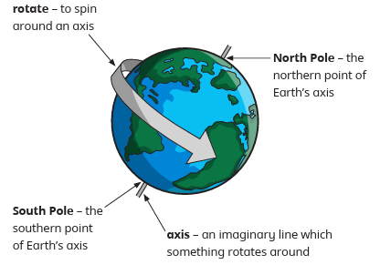

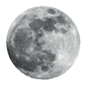
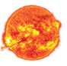
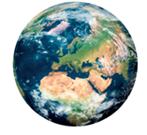

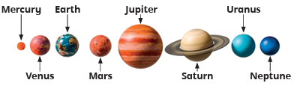
Working Scientifically Skills
- Observe living and non-living things carefully.
- Record findings using tables, diagrams and classification keys.
- Compare similarities and differences.
- Explain reasoning with scientific evidence.
- Evaluate results and identify patterns.

