digest | The body breaks down food to get all of things out of it that it needs to use.
oesophagus | A tube that connects your mouth to your stomach. Food travels down it.
stomach | The stomach contains stomach acid. Stomach acid breaks food down whilst it is in the stomach. The stomach is an organ.
small intestine | The small intestine is a bit like a long tube. As food passes through it, nutrients are absorbed into the body. This is where the good stuff, that you your body needs, is taken out!
large intestine | When food leaves the small intestine, it passes into the large intestine. Water is removed from what is left. Just waste food remains so this is where stools (poo) are made.
rectum | Stools wait here before they leave the body through the anus.
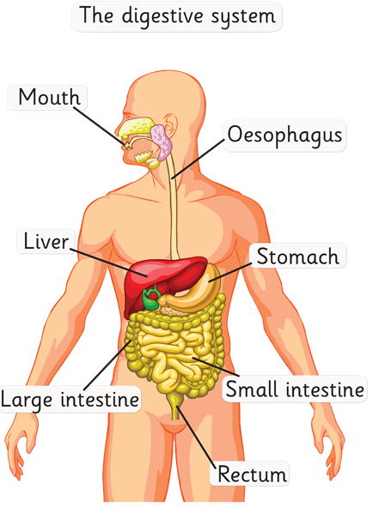

incisors | bites and cuts
canines | tears and rips
pre-molars | crushes and holds food
molars | grinds food down
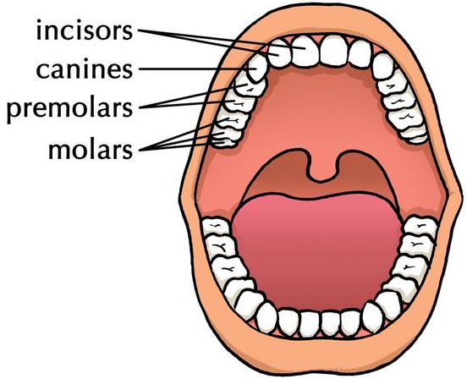

Humans have up to 32 adult teeth. Teeth need to be cleaned at least twice a day and for two minutes each time. Try to use a fluoride tooth paste and visit your dentist for check-ups.
You should try to avoid sugary drinks and foods such as chewy sweets as these can encourage tooth decay.


