

Homework Planner

Theme: Music to my ears!
Autumn Term: second half |  |   Year Group: Four
This half term, we will be exploring how sound travels. Following on from this, we will then be researching different types of music genres and instruments.
We will celebrate all the sounds that we can hear!
Our reading study will be, ‘A Story like the Wind’ by Gill Lewis.

Choice of activity: | Art-based |  | Research-based | Writing-focus
      Please choose one of the following: | If you were a popstar/rock-star/ singer/ rapper, what would your album cover look like?  Design what you would look like on the front cover of your album.  Remember you want to influence and inspire people to buy your music.  What will the title of your album be? How is this important to you?  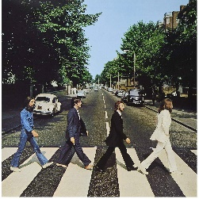    We will display these pieces of album artwork on our homework board. |  | Can you play an instrument? Are you confident at singing?  Research a song which inspires you, learn it and practise it.  You can perform to the class in a mini-concert at the end of term!   | If you could write a song, what would you sing about?  What type of song would it be?  Now is your chance to write your own song.  You can either sing it or just read it to the class.  Or, if you want to be really professional, you could try to record the sound at home!  
Themed tasks to be in: | The week beginning Monday 12th December 2022
Regular, ongoing tasks | Daily reading: 25 minutes at home every day.  Please encourage your child to record their reading progress in their reading journal.  They are expected to do this four times a week.
Regular, ongoing tasks | Times tables to be learned for five minutes every evening using Times Table Rock Stars or other chosen methods.  We’ll use speed tables and Percy Parker sessions in school to see how they are improving.  Short daily sessions of Numbots are also recommended to increase speed and accuracy when working mentally.
Regular, ongoing tasks | Quick bursts of Maths and English homework will be sent out every week.
Regular, ongoing tasks | Spellings to be learned for five minutes every evening leading up to a test fortnightly.  Thank you for your continued support.

