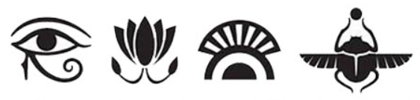
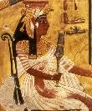
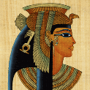
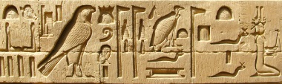
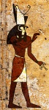
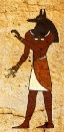
Homework Planner

Theme: Ancient Egyptians
Autumn Term: First half |  | Year Group: Four
This half term, we will be travelling back in time to Ancient Egypt! We will be finding out about the gruesome mummifying process, the awe-inspiring pyramids and the memorable pharaohs. Our class reader this half term will be ‘Mr Stink’ by David Walliams.
Choice of activity: | Art-based |  | Research-based | Writing-focus
Please choose one of the following:  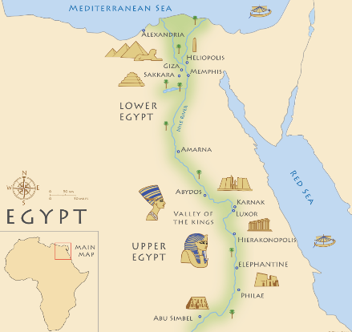 | Create your own Pharaoh mask.  Death masks were made in the likeness of the person who had deceased. They would often have slightly enlarged eyes, a faint smile and also painted jewellery and makeup.  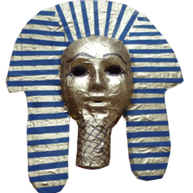  Use any materials that you wish, to create a death mask that looks very expensive and treasured.  We will create a class display of these wonderful pieces of art. |  | Who is your favourite ancient Egyptian pharaoh? Choose one of the many from Ancient Egyptian times and find out as many interesting facts as you can. Maybe it was Tutankhamen? Or Cleopatra?  Find out what they looked like, when they were in power, why they were important and any interesting stories involving them. You might even want to see if you can find out how to write their name in hieroglyphs!  Share this information in a way of your choice: a poster, booklet, diagram and so on.  You will have a chance to share this information with our class and persuade us why your chosen pharaoh is the best. We will then vote for year 4’s favourite pharaoh! | How would you describe Ancient Egypt? Can you think of an interesting way to describe the never-ending sand dunes, the towering pyramids and the significant River Nile?  Write a poem about Ancient Egypt and what you imagine it to have been like. You can decide which style you would like to use.  We’ll add these to our display.  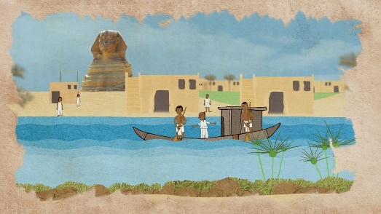
Themed tasks to be in: | The week beginning: Monday 16th October 2023
Regular, ongoing tasks | Daily reading: 25 minutes at home every day
Regular, ongoing tasks | Times tables to be learned for five minutes every evening using Percy Parker songs, Times Table Rock Stars or other chosen methods. We’ll use speed tables sessions in school to see how you are improving…
Regular, ongoing tasks | Quick bursts of Maths and English homework will be sent out every week on a Monday, which will be checked on a Friday.
Regular, ongoing tasks | Spellings to be learned for five minutes every evening leading up to a test fortnightly, on Fridays.  Thank you for all your support with these home tasks.

