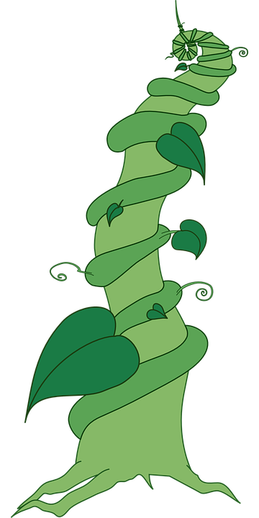
Grow, grow, go!
Year 3 – Summer 2
Plants
Plants have many different parts, which each have a specific function:
• Roots anchor the plant and absorb water and nutrients from the soil.
• The stem holds the plat up and carries water and nutrients to the leaves.
• The leaves make food for the plant using sunlight.
• The flowers make seeds grow into plants and the petals attract pollinators.
Plants need water, light, food and nutrients, air and space to be able to grow well. Different plants may need different amounts of these things. Seeds can be dispersed in a variety of ways: water, dropping, carrying and wind. Seeds get spread to new places and a new plant will grow there. The life cycle of a plant involves many stages: Pollination, fertilisation, seed dispersal, germination and growing. Each stage is important to the process.
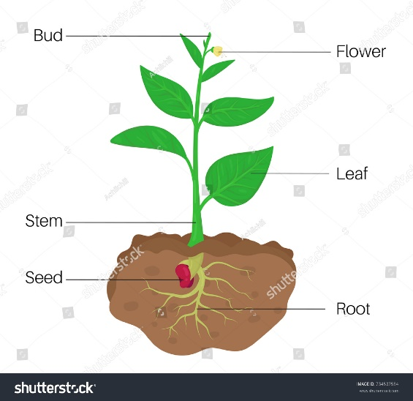
Jack and the Beanstalk
Key vocabulary:
Roots | The part of a plant which attaches it to the ground or to a support.
Stem | The main body or stalk of a plant or shrub.
Flower | The seed-bearing part of a plant.
Leaves | A flattened structure of a plant, typically green and blade-like, that is attached to a stem directly or via a stalk.
Seed | The small parts produced by plants from which new plants grow.
Prediction | A statement that explains what you think will happen.
Conclusion | A conclusion sums up what has happened in an investigation.
Variable | Any one of the elements of the test which could be changed.
Observe | To notice what's going on through your senses, but, more specifically, we can define observation as the act of knowing and recording something.

English
We learn how to write and edit play scripts based on Jack and the Beanstalk. We perform these in class to one another. This a unit of work that is enjoyed by everyone!



