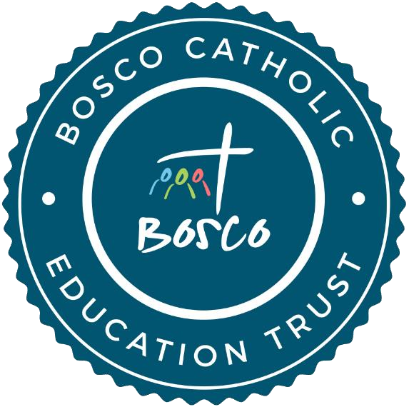

Religious Education Policy

For all schools in the Bosco Catholic Education Trust

This Policy has been approved and adopted by the Bosco Catholic Education Trust.
Approved: | For review:
December 2022 | December 2025

Bosco Catholic Education Trust Mission Statement
The Bosco Catholic Education Trust is a Christ-centred family of Catholic academies, within the Diocese of Arundel and Brighton, working together as one body to provide an outstanding education for all. As Catholic schools, we endeavour to develop confident, compassionate and faithful young people. Through partnership, collaboration and mutual support, we seek to enable all those entrusted to our care to become the person God called them to be.
“Serve the Lord joyfully”

Rationale of Religious Education:
We believe:
- The Catholic ethos of each school should be retained and strengthened particularly with respect to a distinctive Religious Education curriculum, liturgy, collective worship and prayer
- Religious Education to be ‘the core of the core curriculum’
- We are clear that the specific contribution Religious Education makes to the Catholic Life of the school is primarily educational and will be planned, taught, assessed and monitored with the same rigour as other curriculum subjects
- Religious Education is central to the educative mission of the Church
- That evangelisation and catechesis are happening in our school

The Aims of Religious Education

- to promote knowledge and understanding of Catholic faith and life, of the response of faith to the ultimate questions about human life, its origin and purpose
- to promote the skills required to engage in examination of and reflection upon religious belief and practice
- to foster the love of God through knowledge and understanding of the Catholic Faith from scripture and doctrine
- to develop knowledge and understanding of Christianity and other major world religions or value systems adhered to in the UK
- to encourage the development of a personal relationship with God and to be capable of reflecting on their own experiences, and of developing a personal response to the fundamental questions of life
- to have respect for other people’s views, and hence to celebrate diversity in society

Classroom Religious Education should be accorded the same status and taught with the same rigour as the core subjects of the National Curriculum. It is open to inspection and assessment by public examination and at Diocesan level.

RELIGIOUS EDUCATION POLICY
Policy Statement | Success Criteria | Monitoring Procedures
The Trust is committed to supporting our schools in achieving the following: | The Trust consider that the following criteria are evidence of successful implementation of each of the policy statements: | The following procedures will be employed to monitor the success of the policy:
- That Religious Education and the development of a spiritual understanding of life in the Catholic tradition is at the very heart of the curriculum. | - Religious Education is promoted and taught as a core subject studied by all pupils on roll at the school.  - Schemes of work within the Religious Education curriculum have clear reference to opportunities for the development of individual pupil’s spiritual awareness. | - The Trust Board will approve the Religious Education curriculum on an annual basis.  - Departmental/Subject reviews will include reference to student spiritual awareness, reporting back to the Local Governing Committees and this will then inform individual School Improvement Plans.
- That the Religious Education curriculum will present the Judaeo-Christian tradition, in general, and the Catholic faith, in particular, in a way that is rooted both in the Scriptures and in the teaching of the Catholic Church’s magisterium. | - Teaching is rooted both in the Scriptures and in the Church’s Tradition; especially that found within the documents of the Second Vatican Council and the Catechism of the Catholic Church, with reference to any current statements of the Vatican and the Bishop’s Conference of England and Wales. | - A review of the Religious Education curriculum will be undertaken once every two years by the relevant LGC committees and a report tabled to the LGC.
- That the curriculum also seeks to instil within the students an understanding and respect for other world faiths. | - Students are educated in other world faiths at appropriate times throughout Key Stages. | - As above.
- That the curriculum will respect and support each student in their different stages of personal spiritual growth. | - Teaching is sensitive to all students (whether Catholic or from another Christian or other religious tradition) and develops the necessary skills within them to examine and reflect upon religious belief and practice. | - Governors will monitor any issues arising from the bi-annual survey of parents and students.

