A light in the darkness that brings hope.
Label and describe what is happening in this painting.
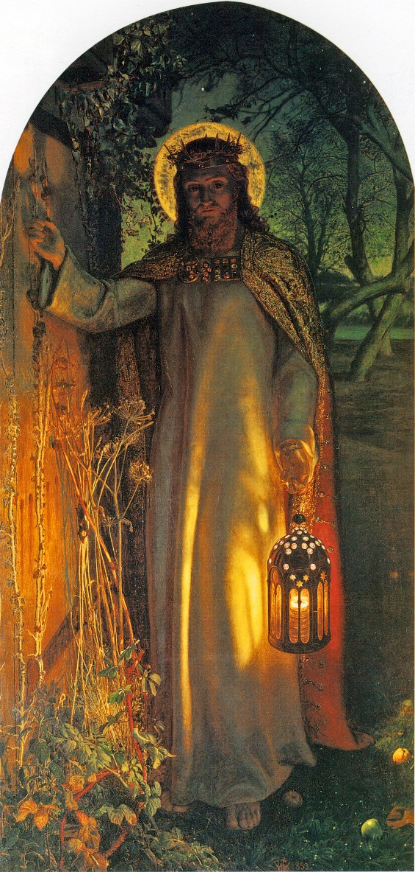

Crown of thorns / Halo / Robes / Woods / Lantern / Door with no handle / Weeds growing around the door / bare feet / Jesus is knocking

A light in the darkness that brings hope.
Make links between the Bible and this painting.

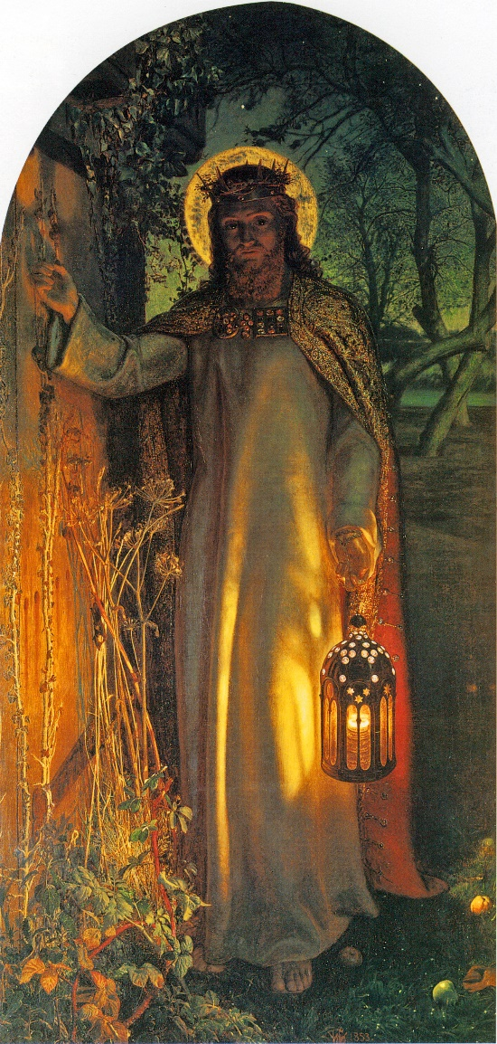

Crown of thorns / Halo / Robes / Woods / Lantern / Door with no handle / Weeds growing around the door / bare feet / Jesus is knocking

A light in the darkness that brings hope.
Show an understanding of how this painting conveys the message of Jesus and the Bible.
Write and describe what the different meanings are of the painting, describing why Jesus was the light of the world and why we still think of him in that way now.

