Use the Word Bank to help you label the flower diagram below. Then, write a description of the male and female parts
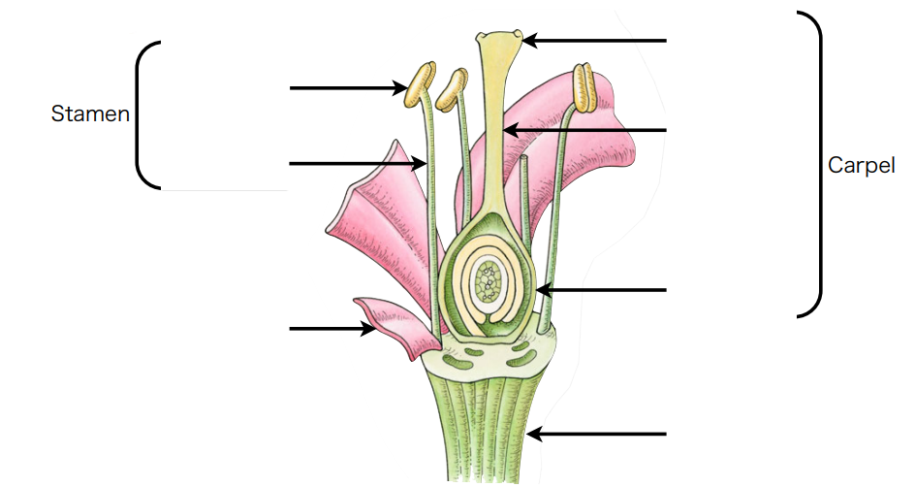
Word Bank
Sepal stigma ovary stem petal filament anther

The stamen _____________________________________ ________________________________________________ ____________________________________________________________________________________________________
The ovary _____________________________________ ________________________________________________ ____________________________________________________________________________________________________

