Can I explain what crime and punishment was like when the Anglo-Saxons and Vikings were rulers?

What was the most common type of crime and how was it punished? Name 3 officials who were associated with keeping the peace?
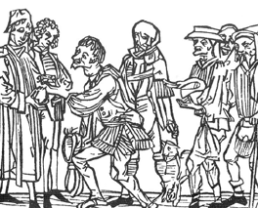

ANGLO-SAXON AND VIKING
Ho
Explain what a trial by ordeal is What was weregild and how was it
and when it was used? used?

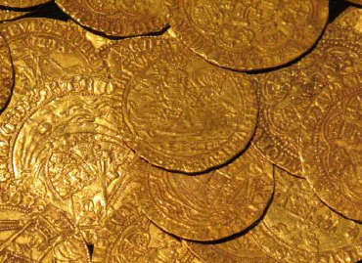

In what cases could a person be put to death as a punishment? What is your opinion of the Anglo-Saxon and Viking justice system and why? system and why?

