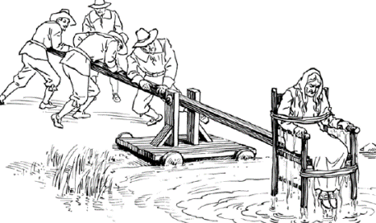
The Normans changed the way people were punished for crimes but not how they were caught and tried in a court. _______________ was abolished, as was trial by __________________. Now people could be fined but the money would go to the _______________ instead of to the __________________.

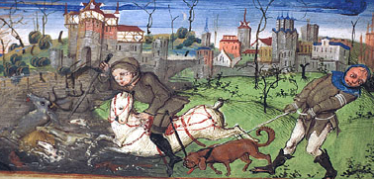
Forests were created so kings could hunt _______. If you lived in a forest you weren't allowed to gather firewood or hunt ________________. Forests covered about one ______________ of England in the later medieval period.

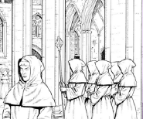
Criminals could seek ___________________ in a church and escape punishment. Crimes against the church, though, like _________________, were judged in special church _________________.

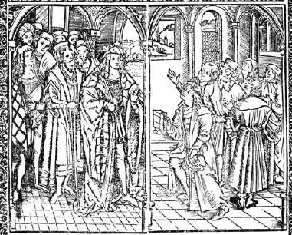
Later in the medieval period, Justices of the _________ were not elected by the local community, but appointed by the _____________. They were part of a move towards central control over law and order. A system in which everyone was involved was giving way to one in which law enforcement was the job of certain _________.

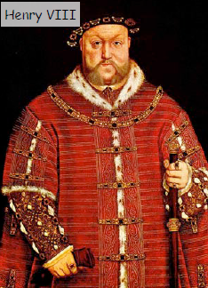
The Tudor King ______________ VIII changed the religion of the country and so lots of people were executed for ________________ or ________________. The punishment for __________________ was being burned at the ______________. King Henry also shut down the ____________________ so the ______________ weren't looked after and instead became homeless and had to beg, which was made a crime.
There are lots more heretics burned at the stake because of the changes in religion in the country. |  | Forests were set up so the king could hunt deer. You weren't allowed to gather firewood in a forest unless you had a licence.
Constables, beadles or watchmen were appointed to prevent crime and catch criminals. |  | Weregild and trial by ordeal were abolished and fines or punishments of shame were used instead.
Criminals were still caught by members of the community and tithingmen would bring people to trial. |  | Justices of the Peace were appointed by the king to control courts and punishments for crimes.
People were put in the stocks or on the ducking stool for minor crimes. |  | Because the monasteries had been shut down, there were more homeless vagrants begging.
There were 80 forests that covered one third of the area of England. |  | Criminals could seek sanctuary in a church and their pursuers could not enter and catch them.
Norman and Early Medieval |  | Late Medieval and Tudor
Summarise the key changes to the justice system in your own words?

heresy | sanctuary |  | monasteries

