Can I explain how crimes were punished in Tudor times?

Tudor Punishments: Use the information sheet to create a poster about Tudor punishments and their related crimes.

Serious Punishments

Hung, drawn and quartered
Being hung, drawn and quartered was a serious punishment for people who committed treason. This involved being hung, your insides being taken out and then your body being chopped into four pieces. These parts were put on display as a warning to others!
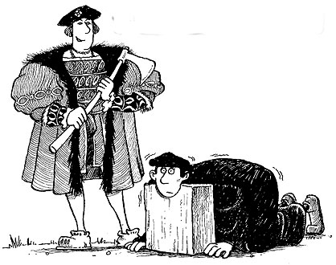
Beheading ("Death by the Axe")
This was a punishment that resulted in your head being chopped off! The heads were sometimes placed on spikes along London Bridge or other places. Beheading was considered less degrading than hanging, and it usually killed more quickly. Noblemen (rich) who committed crimes were more likely to be beheaded than hung.

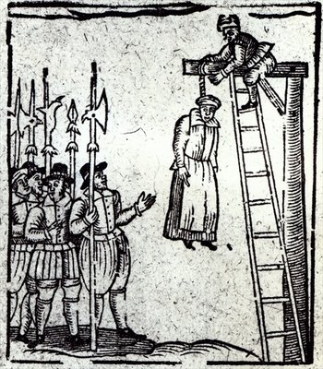
Hanging from the gallows.
A piece of rope was put around the neck making it hard for the person to breathe. The person would be hung from the rope until he/she had stopped breathing and was dead. People were hung for crimes such as stealing, treason, rebellion, riot or murder.

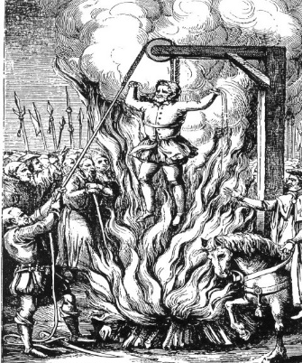

Burning
Women found guilty of either treason or petty treason were sentenced to be burned alive at the stake.

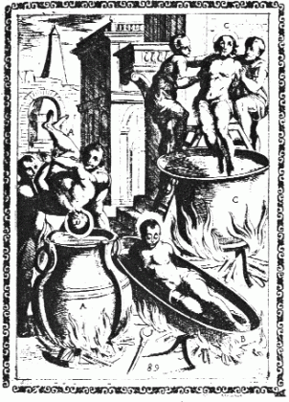

Boiled alive
For attempting to murder someone you could be boiled alive in a big bowl of hot water.

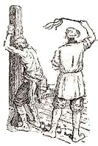

Lesser Punishments

Whipping (flogging)
Many towns had a whipping post. The victim was chained to the post, stripped to the waist and whipped.
You could be whipped for stealing a loaf of bread!
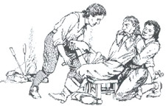
Branding with hot irons
Hot irons were used to burn letters onto the skin of offenders hand, arm or cheek. A murderer would be branded with the letter 'M', vagrants with the letter 'V', and thieves with the letter "T".
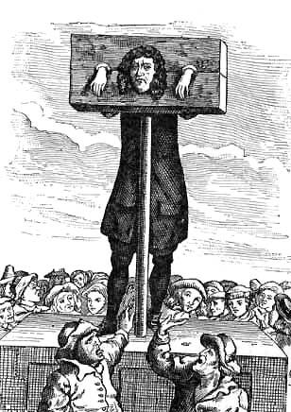

The pillory (standing)
The pillory was a T shaped block of wood with holes for the hands in the crossbar of the T. The person being punished would have to stand in the device in the middle of the market to be ridiculed by passersby.

The stocks (sitting)
Stocks were used in the same way as the pillory, except that with stocks, the feet were bound. The stocks were a block of wood with two holes for your feet to go in. You were put in the stocks for selling bad meat or bread. Local people threw rubbish and rotten eggs at people in the stocks.
You could be put in the stocks for not wearing a hat on Sunday!

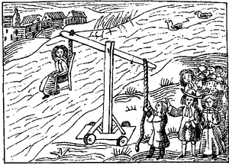
The ducking stool (Punishment for women)
Accused witches were dunked into a river, to see if they were innocent or guilty. If they floated, they were considered guilty and burnt at the stake. If they sank, they were innocent but died anyway, by drowning. Either way, they perished.

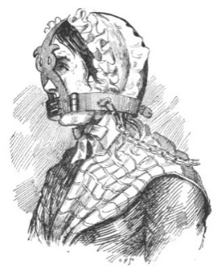
The Brank, (the gossip's bridle)
The brank was a punishment enacted on women who gossiped or spoke too freely. It was a large iron framework placed on the head of the offender, forming a type of cage. There was a metal strip on the brank that fit into the mouth and was either sharpened to a point or covered with spikes so that any movement of the tongue was certain to cause severe injuries to the mouth.
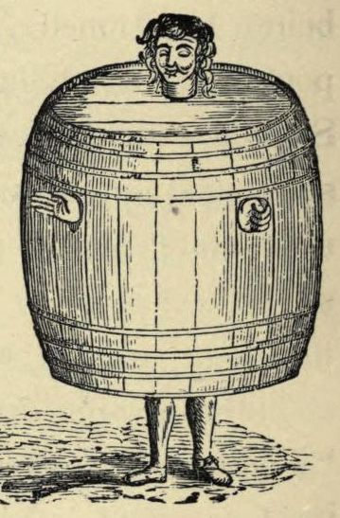
The Drunkard's Cloak
This was a punishment for public drunkenness. The drunk was forced to don a barrel and wander through town while the villagers jeer at him. Holes were cut in the barrel for the person's hands and head, causing it to become like a heavy, awkward shirt.

